**Positionality Paper**

On my first day of Kindergarten at my new elementary school, I learned, much to my dismay, that we had to wear a uniform. I was extremely distraught when I figured out what a uniform meant, and I literally threw a temper tantrum. Then, in a desperate attempt to calm me down and get me dressed so we could make it to school on time, my Mom explained the concept of “accessorizing” to me, and in that moment, a whole new door opened up in my mind. My school’s rules pertaining to the uniform detailed that the uniform must consist of “a **HUNTER GREEN** or **WHITE** collared shirt or blouse and **HUNTER GREEN** or **KHAKI** pants, shorts, skirts, skorts, or jumpers.” So, on my first day of Kindergarten, I showed up to my new school wearing a white blouse and khaki skort, along with a pink feather boa, (fake) pearl necklace, pink cheetah print tights, a pink cardigan with a fur lined collar, and sparkly gold Mary Janes. While I don’t have a picture of that day, I do have an example of one of my day-to-day outfits, this specific outfit was to attend one of my classmate’s birthday parties. As you can see, I loved sparkles and I loved to accessorize.

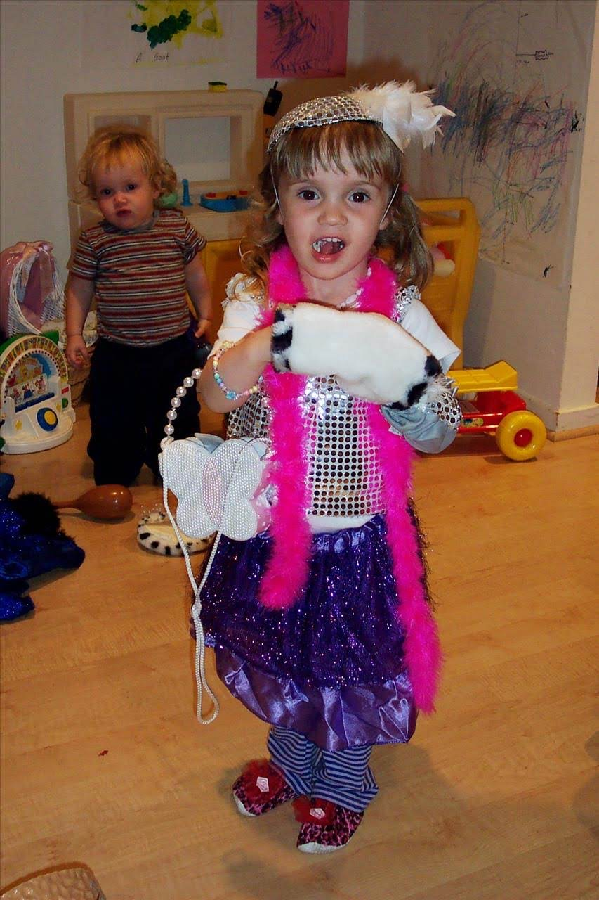

My attitude about nonconformity, although especially present in my style and how I chose to dress, was a value that I held in every other aspect of my life, outside of what I wore. I didn’t want to do what everybody else was doing, even if it made me stick out. In some ways, it was probably outwardly annoying to others at times because I definitely had a very strong individuality complex that sometimes bordered on arrogance. For example, when we were doing a poll of our favorite colors in my first grade class, almost every other girl chose pink or purple as their favorite color, and even though pink and purple were colors I really liked, I just had to say that my favorite color was yellow so I wouldn’t be in the same group as everybody else, despite that not actually being true. However, in hindsight, my consistent efforts to be contrary to the mainstream taught me values that I hold closely to my heart today. I can’t quite pinpoint a time in my life when I started wanting to be contrary. It was just always how I was. I think part of it was growing up in a space where I felt like there were a lot of people around me who did things just because everyone else did. A good example of this is my older cousins. They lived in the suburbs and they all were very blonde and athletic and were always focused on how they looked and would constantly judge people who didn’t look like them. I didn’t like to be around that energy and I would often get really upset when they would talk about “how ugly that girl’s outfit is” or “why does that person’s face look like that” or “why is that person in a wheelchair”? It made me uncomfortable to be associated with people that would speak this way about other humans, and often those humans were children. There are many reasons why I wanted to go against the mainstream when I was younger, but I think this was probably one of the most influential.

Looking back, while these values probably came off as annoying in many ways, one thing that I feel very proud to have always carried with me is sticking up for what I believe in, despite it maybe not being the “popular” opinion, or even if it would mean ostracizing myself from everybody else. When I was in third grade, there was a new student named Mikayla, who, from her first day at school, was bullied because she was bigger than everybody else, along with the fact that she had to be in special classes due to her learning disability. Mikayla was almost always the target of extremely mean jokes made by my classmates, and it always made me feel sick to my stomach when they made fun of her because of how she looked, and also because of a disability that she didn’t ask to be born with. I made a point to play with her every single day at recess, and also asked my teacher to have my desk be moved next to hers. When my classmates would make fun of Mikayla behind her back or even to her face, I would always snap back at them or ask them why they were making fun of her. Looking back, I feel proud that I stood up for Mikayla, I didn’t want her to feel like she had to explain herself to anyone, or feel bad about who she was.

Over time, Mikayla and I became close friends, partly because we spent so much time playing together at recess, and also sat next to each other in class. However, we also discovered that we had many things in common, one of the biggest being our interest in fashion and playing dress up. She began to come over for playdates after school and we would style outfits for each other and put on fashion shows for our parents. I didn’t really understand the impact of my actions until one day when Mikayla and her mom were over, and I came downstairs and saw her mom crying and hugging my mom and saying how thankful she was that Mikayla had found “a friend like me.” She explained that Mikayla had to leave her last two schools because they did not have resources for kids with learning disabilities, and also because she wasn’t shown any kindness or humanity in those schools. Mikayla was relentlessly bullied by her classmates, and teachers did little to nothing about it.

This friendship, among many other impactful friendships I’ve had, taught me so much about “haves” and “have-nots”, and also gave me a reality check with the fact that I did not have to wake up every day feeling like I had to defend myself and my existence to the rest of the world. I was not born with a learning disability, and never really struggled socially in school. I was never called “stupid” or “slow” by anyone, and the way I looked when I was a kid, (as well as now) was considered by the rest of society to be conventionally “healthy” and “acceptable”, whatever that means. I never had my appearance made fun of in school, and I never had to feel like everyone else in my class was making fun of me behind my back for things about me that I could not control. I had never had to think of those things before, and taking a step back from myself made me realize how fortunate I was to never have to worry about any of these things. In addition, I was actually in a position of power because of the fact that I was able to consistently stick up for Mikayla without having to worry about being made fun of, or having my own identity brought into question. From what I remember, people didn’t really ever make fun of me to my face, because I made it clear that I could defend not just Mikayla, but also myself. In addition, I think my peers knew they wouldn’t really get anything out of teasing me, because it genuinely didn’t bother me and I did not really give any sort of reaction because I really did not care what they had to say about me. Additionally, I had the privilege of not having too many things about me that people would make fun of. The few things I can remember people making fun of me for were the way I dressed (which I couldn’t have cared less about what they thought because I LOVED my style and I got lots of compliments from people whose opinion I did care about, like my teachers).

The only other thing I can remember people making fun of me for, which is probably one of the dumbest things ever, is that I have a big forehead. Everyone on my Mom’s side of the family has a big forehead, so I always loved my forehead because it connected me to the rest of my family. My Mom also used to tell me that my forehead was so big because “all that brain power had to go somewhere”. Therefore, I didn’t care what other kids had to say. I loved myself and I loved my style and I loved how I looked. I didn’t understand this at the time, but because of certain aspects of my appearance, my identity, and as stupid as it is, my social standing in elementary school, I was able to rise above their means words and relentlessly stick up for my friend, because I never had to worry about those things in terms of myself.

While this story is an important foundation of my identity, I don’t want to paint myself as some sort of wonder child who should be put on a pedestal for doing what no other child had done. A large part of my actions and beliefs are a result of how I was raised. Throughout my life, especially when I was younger, my parents always pushed my siblings and I to recognize that in most cases in life, we would be in positions of privilege, due to our race, family background, socioeconomic status, etc. In addition to pushing us to acknowledge our privilege, my parents also stressed the importance of justice and sticking up for the underdog, instead of following the crowd and trying to blend in with everybody else by ignoring injustices in the world. My mom especially, was a big influence on my values. My mom is probably one of the kindest people on this Earth. She has a soft spot for all beings that are vulnerable, especially baby animals, baby humans, etc, but also anyone who is considered an “underdog” by the rest of the world. She was always kind to everyone she met, and tried to meet them on their level in a way that wasn’t patronizing. When I was really young, she would babysit our family friend’s son, Charlie, who was autistic and non-verbal. None of my parent’s other friends would offer to babysit him because they didn’t really want to deal with his outbursts due to his sensory issues or all the special care that he needed to communicate, eat, go to the bathroom, etc. However my mom was happy to not only help his parents out and give them a break, but also happy to interact with Charlie because he was a really sweet kid. She always had my siblings and I helped her watch him because she wanted us to have the opportunity to interact with people who were different from us, people who would normally be ignored or patronized by the rest of society. We learned how to play with Charlie in ways that were comfortable for him and also learned to be sensitive to special needs that others might have, in Charlie’s case, his sensory issues and communication barriers. My siblings were similar to me for this reason. Both my brother and sister have very very innate senses of justice and fairness. They are different from me in that they weren’t as flamboyant as me (when we were little), and don’t have as much of the “I don’t care” attitude that I do. However, the values that my parents, especially my mom, instilled in us throughout our childhood still remain true.

I was very lucky to have my privilege checked at a young age, through my parents' reminders, experiences like my friendship with Mikayla, etc. I also grew up in Washington, DC and attended public schools for the entirety of my education career, where I was often one of a few white kids in my class. I was born at a major turning point for schools in my area of the city (Capitol Hill/Navy Yard area), as almost every class after mine was affected by the gentrification of the neighborhood that my school was in. My school was in the Capitol Hill neighborhood, where the Capitol is, and in the last 20 years has become almost exclusively made up of upper-middle class white people, whereas the neighborhood used to be populated by low income Black families.

Therefore, my class was one of the last classes where there were majority Black students. I believe this gave me more of an insight and reminder of my inherent privilege as a white person, because so many of my classmates and their families were experiencing racism and discrimination, and unfortunately the fact that there were more Black students in my school made this racism all the more visible and present.

Furthermore, and keeping all of the aforementioned in mind, I want to spend the rest of this essay delving deeper into how my identity and core values were continuously deconstructed and reconstructed throughout my life through different experiences, relationships, and lessons I’ve learned/am learning.

I began this essay talking about my lifelong attraction to nonconformity and my aversion to the mainstream. One of the biggest a-ha moments I’ve had in my life was in high school, in AP World History. We were learning about the Holocaust, and about how in Nazi occupied territories, Jewish people had to wear a yellow star on their clothing whenever they left the house, proclaiming to the rest of the world that they were inferior, that they were what was wrong with society, and they were, according to Hitler and his followers, the reason why Germany was doing so poorly economically and otherwise. This is a very complex connection and thought process I had, so bear with me as I explain. My teacher made a remark during this lesson about how wearing these stars did away with every other part of the person wearing it, and reduced them down to the fact that they were not a part of the idealized “Aryan” race.As a Jewish person myself, I cannot imagine that one aspect of my identity being something that completely encapsulates myself and how the rest of the world views me. I thought about that lesson for a long time after it was taught, and it led me to think more about what being Jewish in the present world looks like. I am ethnically only ¼ Jewish, my dad’s dad was an Ashkenazi Jew whose family immigrated from Eastern Europe in the 1920s. Therefore, while I identify as Jewish because of the traditions passed down through the generations of my family, I don’t “look” like a traditionally Ashkenazi Jewish person, and neither does most of my family. My dad always jokes that the only genetically “Jewish” trait he passed down to my siblings and I is being lactose intolerant and having major stomach issues. This goes back to a point I made earlier about the privilege I was born with of never having to explain myself, my identity, or my appearance to anyone. Objectively, I look like a “stereotypical” American woman. I am white, I am 5’4”, I have long brown hair, I do not have any physical disabilities, and the way I dress (for the most part) aligns with societal norms of what people of my gender identity, as well as the sex I was assigned at birth “should” dress like. Since my childhood, I have toned down my style a bit, especially because I often dress for comfort instead of style now that I’m in college. However, despite how eccentric my style is/was, I still dress in a way that people would associate with how a “woman” would dress. In a room full of different types of people, I do not stick out as anything out of the ordinary in terms of the socially constructed definition of “normal”, the only characteristic that could be seen as abnormal is the fact that I have many tattoos all over my body, especially on my arms. Besides that, I would be considered, based on American standards of beauty/appearance, the norm. At face value, I do not look like I belong to any marginalized group, besides the fact that I’m a woman, but even so, I am a *white* woman. This fact has afforded me many privileges throughout my life, some that might not even be visible to me, because I was born on “third base”. The reference to “third base” comes from an analogy relating to baseball, meaning that I was born in a position of privilege without having to do much to earn it.

This thought of my appearance and my background and the privileges was nothing new, because as I said before, I was very lucky to grow up with parents that obligated me to examine my privilege at a very young age. However, this one AP World History lesson in my sophomore year of high school caused me to discover a new thread of connection to how I view my identity and my core values. This specific lesson happened to coincide with a time in my life where I was feeling particularly contrary to the mainstream, and yearned to be a part of “alternative” culture, meaning fashion, music, etc. I had started to experiment with dying my hair, giving myself stick and poke tattoos (much to the dismay of my parents), wearing different types of clothing, and listening to music that I thought was “different” and unlike what my peers were listening to.

After spending my days thinking about this specific lesson in AP World History and the series of queries and curiosities it had sparked within me, I realized why I had been thinking about it so much in relation to my own identity. The big a-ha moment was when I realized that I could make the *choice* to stick out and be “different” through dying my hair and wearing certain clothes, whereas others did not have that same privilege. Some people were born with certain characteristics, identities, etc, that would force them to be on the outside for their entire lives, whether they liked it or not, and they couldn’t just dye their hair back to brown or wear a long sleeve shirt to cover up their tattoos.

This seems like a very basic concept to be discovering at 15 years old, when I probably should have been discovering and grappling with more complex and difficult topics, however it provided me with a much necessary reality check, in that I was always going to be able to make the choice to go back and forth between being “normal” and sticking out, but not everyone had that same choice. Instead of focusing all my energy on trying to make myself appear to others as “different” and “alternative,” I could focus that energy on using my place of privilege to show up for people who did not have those same privileges that I am afforded. Instead of trying to express my aversion to the mainstream in vanity and material-based actions, I could take action and not remain complacent in the injustices around me. I could take notes from my younger self, who was befriending someone because I felt strongly that this person deserves kindness and empathy just like everyone else, and not because I was trying to perform to make myself appear a certain way to everyone else. The nature of performing to appease the larger culture is doing exactly what I didn’t want to do, which is being a complacent follower in the face of injustice.